Data Communication between LWC Components
Refer anotherChildComponent and anotherParentComponent
There are three types of communication between LWC Components:

- Parent to Child Communication
- Child to Parent Communication
- Communication between unrelated components

2. Child to Parent Communication
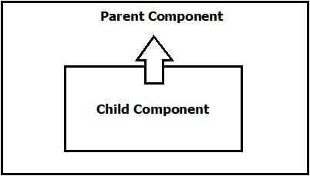

It is done by Custom Event.

Program Code (childComponent4.html)
<template>
<lightning-card>
<lightning-input label="Enter Name" onchange={handleChange}></lightning-input>
<lightning-button label="Click Here" onclick={handleClick}></lightning-button>

</lightning-card>

</template>

Program Code (childComponent4.js)
import { LightningElement } from 'lwc';

export default class ChildComponent4 extends LightningElement {
name='';

handleChange(event)
{
this.name=event.target.value;
}

handleClick(event)
{
const searchEvent=new CustomEvent('getsearchevent',{detail:this.name});
this.dispatchEvent(searchEvent);
}
}

Program Code (childComponent4.js-meta.xml)
<?xml version="1.0" encoding="UTF-8"?>
<LightningComponentBundle xmlns="http://soap.sforce.com/2006/04/metadata">
<apiVersion>58.0</apiVersion>
<isExposed>false</isExposed>
</LightningComponentBundle>

Program Code (parentComponent4.html)
<template>
<lightning-card>
<c-child-component4 ongetsearchevent={handleEvent}></c-child-component4>
</lightning-card>

<lightning-card>
Name: {name}
</lightning-card>

</template>

Program Code (parentComponent4.js)
import { LightningElement } from 'lwc';

export default class ParentComponent4 extends LightningElement {
name='';

handleEvent(event)
{
this.name=event.detail;
}
}

Program Code (parentComponent4.js-meta.xml)
<?xml version="1.0" encoding="UTF-8"?>
<LightningComponentBundle xmlns="http://soap.sforce.com/2006/04/metadata">
<apiVersion>58.0</apiVersion>
<isExposed>true</isExposed>
<targets>
<target>lightning__AppPage</target>
</targets>
</LightningComponentBundle>

